Guanzhen Qian

Per 6-8 Cisco CCNP

OSPFv2 Lab Write Up

Purpose

Set up four routers and four end devices with OSPF running as IP route protocol between different networks. Try to efficiently manage IP address. The goal is to make end devices able to connect to each other (ping each other).

Background Information on lab concepts

Open Shortest Path First (OSPF) is a routing protocol for Internet Protocol (IP) networks. OSPF was developed as an alternative for Routing Information Protocol (RIP), for it offers faster convergence and scales to much larger network implementations. OSPF is a link-state routing protocol that uses the concept of areas (a link-state is the status of router interfaces or connecting networks). A network administrator can divide the routing domain into distinct areas to help control routing update traffic.

Lab Summary

I first placed four PCs and four Routers in packer tracer and connected them according to their ports (Ethernet cable between Ethernet and Gigabyte ports, Serial cable between Serial ports). Then I set their IPv4 address as the network diagram below. At last I set up the OSPfv2 protocol by enabling it on the routers and addressing their directly connected networks.

Lab Commands

Router (Config) # interface *interface*

Router (Config-if) # ip address *ip-address subnet-mask*

Router (Config) # router ospf *process-id*

Router (Config-router) # network *network-address wildcard-mask* area *area-id*

Network Diagram with IP’s

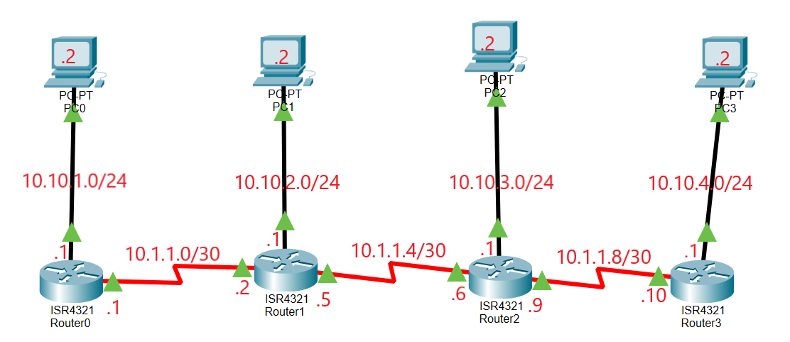

Configurations

Router0

Show Run

*Building configuration...*

*Current configuration : 812 bytes*

*!*

*version 15.4*

*no service timestamps log datetime msec*

*no service timestamps debug datetime msec*

*no service password-encryption*

*!*

*hostname R0*

*!*

*!*

*!*

*!*

*!*

*!*

*!*

*!*

*no ip cef*

*no ipv6 cef*

*!*

*!*

*!*

*!*

*!*

*!*

*!*

*!*

*!*

*!*

*!*

*!*

*spanning-tree mode pvst*

*!*

*!*

*!*

*!*

*!*

*!*

*interface GigabitEthernet0/0/0*

*ip address 10.10.1.1 255.255.255.0*

*duplex auto*

*speed auto*

*!*

*interface GigabitEthernet0/0/1*

*no ip address*

*duplex auto*

*speed auto*

*shutdown*

*!*

*interface Serial0/1/0*

*ip address 10.1.1.1 255.255.255.252*

*!*

*interface Serial0/1/1*

*no ip address*

*clock rate 2000000*

*shutdown*

*!*

*interface Vlan1*

*no ip address*

*shutdown*

*!*

*router ospf 10*

*log-adjacency-changes*

*network 10.10.1.0 0.0.0.255 area 0*

*network 10.1.1.0 0.0.0.3 area 0*

*!*

*ip classless*

*!*

*ip flow-export version 9*

*!*

*!*

*!*

*!*

*!*

*!*

*!*

*!*

*line con 0*

*!*

*line aux 0*

*!*

*line vty 0 4*

*login*

*!*

*!*

*!*

*end*

Show IP Route

*Codes: L - local, C - connected, S - static, R - RIP, M - mobile, B - BGP*

*D - EIGRP, EX - EIGRP external, O - OSPF, IA - OSPF inter area*

*N1 - OSPF NSSA external type 1, N2 - OSPF NSSA external type 2*

*E1 - OSPF external type 1, E2 - OSPF external type 2, E - EGP*

*i - IS-IS, L1 - IS-IS level-1, L2 - IS-IS level-2, ia - IS-IS inter area*

*\* - candidate default, U - per-user static route, o - ODR*

*P - periodic downloaded static route*

*Gateway of last resort is not set*

*10.0.0.0/8 is variably subnetted, 9 subnets, 3 masks*

*C 10.1.1.0/30 is directly connected, Serial0/1/0*

*L 10.1.1.1/32 is directly connected, Serial0/1/0*

*O 10.1.1.4/30 [110/128] via 10.1.1.2, 00:12:04, Serial0/1/0*

*O 10.1.1.8/30 [110/192] via 10.1.1.2, 00:11:54, Serial0/1/0*

*C 10.10.1.0/24 is directly connected, GigabitEthernet0/0/0*

*L 10.10.1.1/32 is directly connected, GigabitEthernet0/0/0*

*O 10.10.2.0/24 [110/65] via 10.1.1.2, 00:12:04, Serial0/1/0*

*O 10.10.3.0/24 [110/129] via 10.1.1.2, 00:11:54, Serial0/1/0*

*O 10.10.4.0/24 [110/193] via 10.1.1.2, 00:11:54, Serial0/1/0*

Router 1

Show Run

*Building configuration...*

*Current configuration : 857 bytes*

*!*

*version 15.4*

*no service timestamps log datetime msec*

*no service timestamps debug datetime msec*

*no service password-encryption*

*!*

*hostname R1*

*!*

*!*

*!*

*!*

*!*

*!*

*!*

*!*

*no ip cef*

*no ipv6 cef*

*!*

*!*

*!*

*!*

*!*

*!*

*!*

*!*

*!*

*!*

*!*

*!*

*spanning-tree mode pvst*

*!*

*!*

*!*

*!*

*!*

*!*

*interface GigabitEthernet0/0/0*

*ip address 10.10.2.1 255.255.255.0*

*duplex auto*

*speed auto*

*!*

*interface GigabitEthernet0/0/1*

*no ip address*

*duplex auto*

*speed auto*

*shutdown*

*!*

*interface Serial0/1/0*

*ip address 10.1.1.5 255.255.255.252*

*!*

*interface Serial0/1/1*

*ip address 10.1.1.2 255.255.255.252*

*clock rate 2000000*

*!*

*interface Vlan1*

*no ip address*

*shutdown*

*!*

*router ospf 10*

*log-adjacency-changes*

*network 10.1.1.0 0.0.0.3 area 0*

*network 10.10.2.0 0.0.0.255 area 0*

*network 10.1.1.4 0.0.0.3 area 0*

*!*

*ip classless*

*!*

*ip flow-export version 9*

*!*

*!*

*!*

*!*

*!*

*!*

*!*

*!*

*line con 0*

*!*

*line aux 0*

*!*

*line vty 0 4*

*login*

*!*

*!*

*!*

*end*

Show IP Route

*Codes: L - local, C - connected, S - static, R - RIP, M - mobile, B - BGP*

*D - EIGRP, EX - EIGRP external, O - OSPF, IA - OSPF inter area*

*N1 - OSPF NSSA external type 1, N2 - OSPF NSSA external type 2*

*E1 - OSPF external type 1, E2 - OSPF external type 2, E - EGP*

*i - IS-IS, L1 - IS-IS level-1, L2 - IS-IS level-2, ia - IS-IS inter area*

*\* - candidate default, U - per-user static route, o - ODR*

*P - periodic downloaded static route*

*Gateway of last resort is not set*

*10.0.0.0/8 is variably subnetted, 10 subnets, 3 masks*

*C 10.1.1.0/30 is directly connected, Serial0/1/1*

*L 10.1.1.2/32 is directly connected, Serial0/1/1*

*C 10.1.1.4/30 is directly connected, Serial0/1/0*

*L 10.1.1.5/32 is directly connected, Serial0/1/0*

*O 10.1.1.8/30 [110/128] via 10.1.1.6, 00:07:56, Serial0/1/0*

*O 10.10.1.0/24 [110/65] via 10.1.1.1, 00:07:56, Serial0/1/1*

*C 10.10.2.0/24 is directly connected, GigabitEthernet0/0/0*

*L 10.10.2.1/32 is directly connected, GigabitEthernet0/0/0*

*O 10.10.3.0/24 [110/65] via 10.1.1.6, 00:07:56, Serial0/1/0*

*O 10.10.4.0/24 [110/129] via 10.1.1.6, 00:07:56, Serial0/1/0*

Router 2

Show Run

*Building configuration...*

*Current configuration : 857 bytes*

*!*

*version 15.4*

*no service timestamps log datetime msec*

*no service timestamps debug datetime msec*

*no service password-encryption*

*!*

*hostname R2*

*!*

*!*

*!*

*!*

*!*

*!*

*!*

*!*

*no ip cef*

*no ipv6 cef*

*!*

*!*

*!*

*!*

*!*

*!*

*!*

*!*

*!*

*!*

*!*

*!*

*spanning-tree mode pvst*

*!*

*!*

*!*

*!*

*!*

*!*

*interface GigabitEthernet0/0/0*

*ip address 10.10.3.1 255.255.255.0*

*duplex auto*

*speed auto*

*!*

*interface GigabitEthernet0/0/1*

*no ip address*

*duplex auto*

*speed auto*

*shutdown*

*!*

*interface Serial0/1/0*

*ip address 10.1.1.9 255.255.255.252*

*!*

*interface Serial0/1/1*

*ip address 10.1.1.6 255.255.255.252*

*clock rate 2000000*

*!*

*interface Vlan1*

*no ip address*

*shutdown*

*!*

*router ospf 10*

*log-adjacency-changes*

*network 10.1.1.4 0.0.0.3 area 0*

*network 10.10.3.0 0.0.0.255 area 0*

*network 10.1.1.8 0.0.0.3 area 0*

*!*

*ip classless*

*!*

*ip flow-export version 9*

*!*

*!*

*!*

*!*

*!*

*!*

*!*

*!*

*line con 0*

*!*

*line aux 0*

*!*

*line vty 0 4*

*login*

*!*

*!*

*!*

*end*

Show IP Route

*Codes: L - local, C - connected, S - static, R - RIP, M - mobile, B - BGP*

*D - EIGRP, EX - EIGRP external, O - OSPF, IA - OSPF inter area*

*N1 - OSPF NSSA external type 1, N2 - OSPF NSSA external type 2*

*E1 - OSPF external type 1, E2 - OSPF external type 2, E - EGP*

*i - IS-IS, L1 - IS-IS level-1, L2 - IS-IS level-2, ia - IS-IS inter area*

*\* - candidate default, U - per-user static route, o - ODR*

*P - periodic downloaded static route*

*Gateway of last resort is not set*

*10.0.0.0/8 is variably subnetted, 10 subnets, 3 masks*

*O 10.1.1.0/30 [110/128] via 10.1.1.5, 00:10:36, Serial0/1/1*

*C 10.1.1.4/30 is directly connected, Serial0/1/1*

*L 10.1.1.6/32 is directly connected, Serial0/1/1*

*C 10.1.1.8/30 is directly connected, Serial0/1/0*

*L 10.1.1.9/32 is directly connected, Serial0/1/0*

*O 10.10.1.0/24 [110/129] via 10.1.1.5, 00:10:36, Serial0/1/1*

*O 10.10.2.0/24 [110/65] via 10.1.1.5, 00:10:36, Serial0/1/1*

*C 10.10.3.0/24 is directly connected, GigabitEthernet0/0/0*

*L 10.10.3.1/32 is directly connected, GigabitEthernet0/0/0*

*O 10.10.4.0/24 [110/65] via 10.1.1.10, 00:10:36, Serial0/1/0*

Router 3

Show Run

*Building configuration...*

*Current configuration : 833 bytes*

*!*

*version 15.4*

*no service timestamps log datetime msec*

*no service timestamps debug datetime msec*

*no service password-encryption*

*!*

*hostname R3*

*!*

*!*

*!*

*!*

*!*

*!*

*!*

*!*

*no ip cef*

*no ipv6 cef*

*!*

*!*

*!*

*!*

*!*

*!*

*!*

*!*

*!*

*!*

*!*

*!*

*spanning-tree mode pvst*

*!*

*!*

*!*

*!*

*!*

*!*

*interface GigabitEthernet0/0/0*

*ip address 10.10.4.1 255.255.255.0*

*duplex auto*

*speed auto*

*!*

*interface GigabitEthernet0/0/1*

*no ip address*

*duplex auto*

*speed auto*

*shutdown*

*!*

*interface Serial0/1/0*

*no ip address*

*clock rate 2000000*

*shutdown*

*!*

*interface Serial0/1/1*

*ip address 10.1.1.10 255.255.255.252*

*clock rate 2000000*

*!*

*interface Vlan1*

*no ip address*

*shutdown*

*!*

*router ospf 10*

*log-adjacency-changes*

*network 10.10.4.0 0.0.0.255 area 0*

*network 10.1.1.8 0.0.0.3 area 0*

*!*

*ip classless*

*!*

*ip flow-export version 9*

*!*

*!*

*!*

*!*

*!*

*!*

*!*

*!*

*line con 0*

*!*

*line aux 0*

*!*

*line vty 0 4*

*login*

*!*

*!*

*!*

*end*

Show IP Route

*Codes: L - local, C - connected, S - static, R - RIP, M - mobile, B - BGP*

*D - EIGRP, EX - EIGRP external, O - OSPF, IA - OSPF inter area*

*N1 - OSPF NSSA external type 1, N2 - OSPF NSSA external type 2*

*E1 - OSPF external type 1, E2 - OSPF external type 2, E - EGP*

*i - IS-IS, L1 - IS-IS level-1, L2 - IS-IS level-2, ia - IS-IS inter area*

*\* - candidate default, U - per-user static route, o - ODR*

*P - periodic downloaded static route*

*Gateway of last resort is not set*

*10.0.0.0/8 is variably subnetted, 9 subnets, 3 masks*

*O 10.1.1.0/30 [110/192] via 10.1.1.9, 00:02:30, Serial0/1/1*

*O 10.1.1.4/30 [110/128] via 10.1.1.9, 00:02:30, Serial0/1/1*

*C 10.1.1.8/30 is directly connected, Serial0/1/1*

*L 10.1.1.10/32 is directly connected, Serial0/1/1*

*O 10.10.1.0/24 [110/193] via 10.1.1.9, 00:02:30, Serial0/1/1*

*O 10.10.2.0/24 [110/129] via 10.1.1.9, 00:02:30, Serial0/1/1*

*O 10.10.3.0/24 [110/65] via 10.1.1.9, 00:02:30, Serial0/1/1*

*C 10.10.4.0/24 is directly connected, GigabitEthernet0/0/0*

*L 10.10.4.1/32 is directly connected, GigabitEthernet0/0/0*

Problems

The problem I encounter is that different networks were not connected, and I knew that because I can ping IP addresses within each network. The problem is that there were not any network statements under OSPF. I solved the problem by entering network statements under all routers.

Conclusion

In this lab, I reviewed the concept of assigning IP address and Point-to-Point OSPF from last year’s curriculum. The Lab took about 45 minutes total. About half of the time was used to plan out IP addresses and other half of the time used to enter commands.

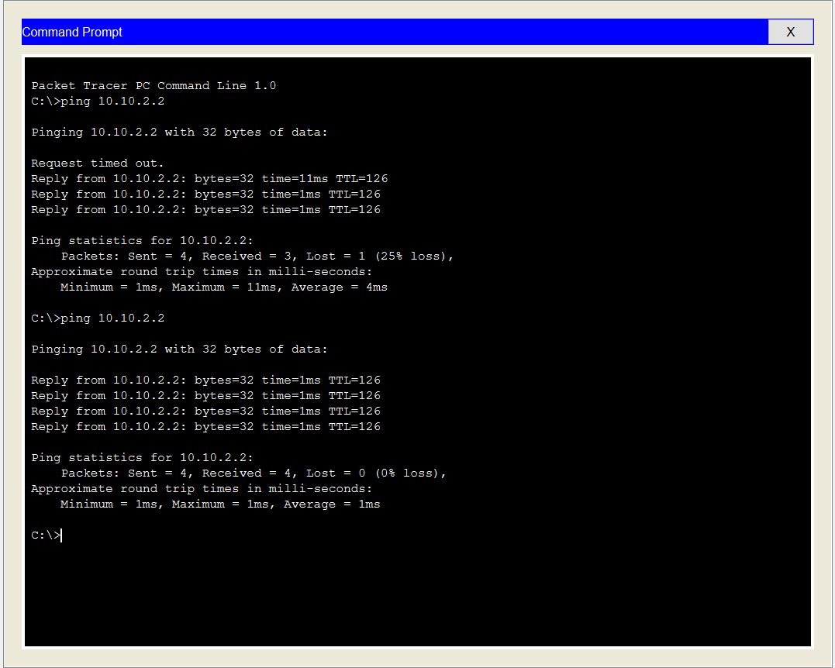

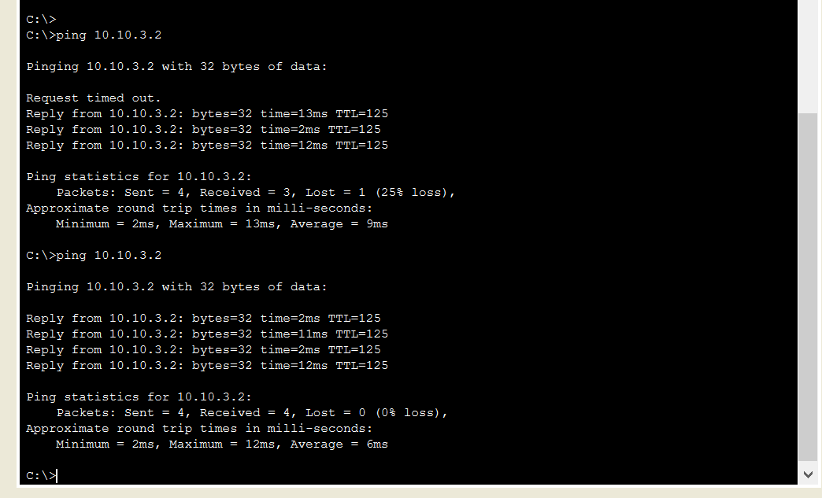

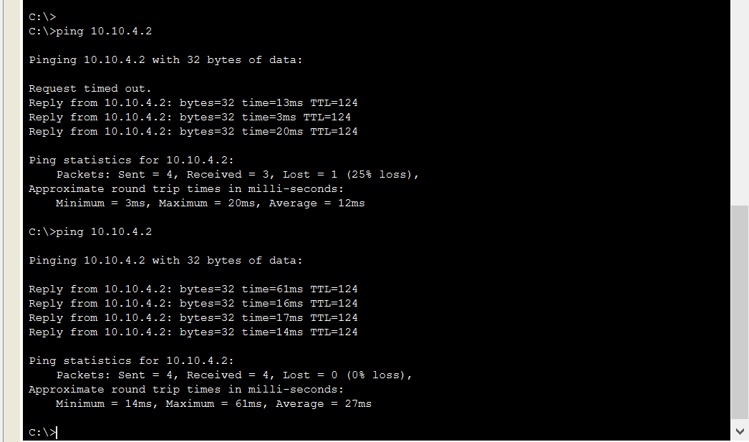

Teacher Signoff Page of Lab Completed